**Libraries To Be Imported :**

Open Pycharm

Created Face_detection.py file under CIS folder

Open the command prompt and install the given packages - dlib,numpy,pillow. Also libraries -face_recognition, openvc python(pip install opencv python == 4.4.0.40)

**dklib:**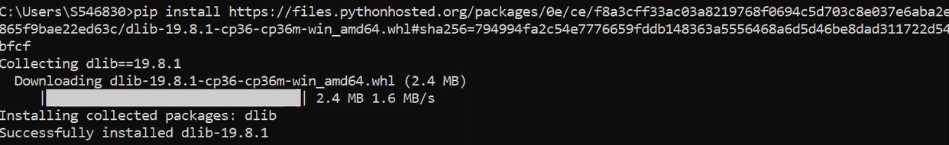

**Face_recognition,pillow,numpy:**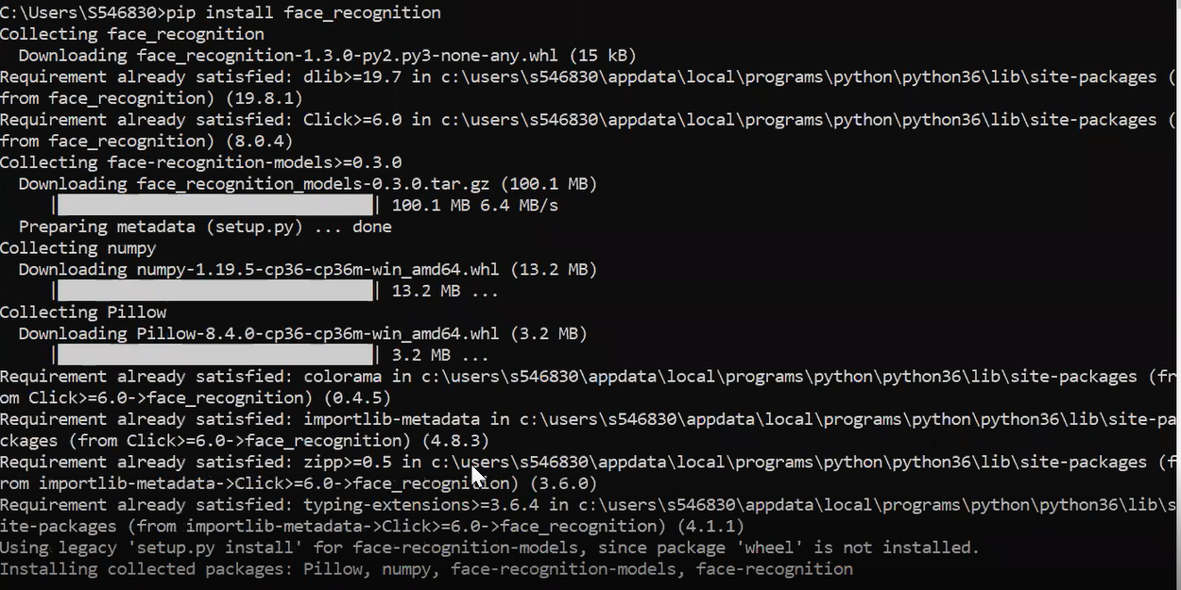

**Open cv python:**

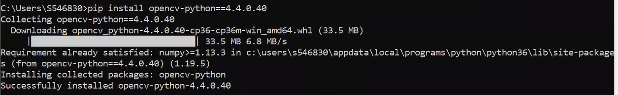

**Open cv python method :**

**OpenCV-Python** is a library of Python bindings designed to solve computer vision problems. cv2.rectangle() method is used to draw a rectangle on any image.

**Syntax:** cv2.rectangle(image, start_point, end_point, color, thickness)

**Parameters:**  
**image:** It is the image on which rectangle is to be drawn.  
**start_point:** It is the starting coordinates of rectangle. The coordinates are represented as tuples of two values i.e. (**X** coordinate value, **Y** coordinate value).  
**end_point:** It is the ending coordinates of rectangle. The coordinates are represented as tuples of two values i.e. (**X** coordinate value, **Y** coordinate value).  
**color:** It is the color of border line of rectangle to be drawn. For **BGR**, we pass a tuple. eg: (255, 0, 0) for blue color.  
**thickness:** It is the thickness of the rectangle border line in **px**. Thickness of **-1 px** will fill the rectangle shape by the specified color.

**Return Value:** It returns an image.